2024
VCE
Specialist Mathematics
Year 12
Trial Examination 1

Detailed Answers



Kilbaha Education (Est. 1978) (ABN 47 065 111 373)  PO Box 3229  Cotham Vic 3101  Australia | PayID: 47065111373  Email: kilbaha@gmail.com  Tel: (03) 9018 5376  Web: https://kilbaha.com.au

All publications from Kilbaha Education are digital and are supplied to the purchasing school in both WORD and PDF formats with a school site licence to reproduce for students
in both print and electronic formats.

IMPORTANT COPYRIGHT NOTICE

- This material is copyright. Subject to statutory exception and to the provisions of the relevant collective licensing agreements, no reproduction of any part may take place without the written permission of Kilbaha Education.
- The contents of this work are copyrighted. Unauthorised copying of any part of this work is illegal and detrimental to the interests of the author.
- For authorised copying within Australia please check that your institution has a licence from http://copyright.com.au. This permits the copying of small parts of the material, in limited quantities, within the conditions set out in the licence.

Reproduction and communication for educational purposes The Australian Copyright Act 1968 (the Act) allows a maximum of one chapter or 10% of the pages of this work, to be reproduced and/or communicated by any educational institution for its educational purposes provided that educational institution (or the body that administers it) has given a remuneration notice to Copyright Agency Limited (CAL) under the Act.

For details of the CAL licence for educational institutions contact CAL,
Email: info@copyright.com.au

- All of these pages must be counted in Copyright Agency Limited (CAL) surveys

- This file must not be uploaded to the Internet.

These suggested answers have no official status.

While every care has been taken, no guarantee is given that these answers are free from error. Please contact us if you believe you have found an error.

CAUTION NEEDED!
All Web Links when created linked to appropriate Web Sites. Teachers and parents must always check links before using them with students to ensure that students are protected from unsuitable Web Content. Kilbaha Education is not responsible for links that have been changed in this document or links that have been redirected.

Kilbaha Education (Est. 1978) (ABN 47 065 111 373)  PO Box 3229  Cotham Vic 3101  Australia | PayID: 47065111373  Email: kilbaha@gmail.com  Tel: (03) 9018 5376  Web: https://kilbaha.com.au

Question 1

a. , separating the variables
to find c, when A1
M1
A1

b. when ,
using implicit differentiation
M1
A1

Question 2

domain

i. a vertical asymptote at and an oblique asymptote at . A1
ii.
when ,
so there are turning points at A1
iii. so there are no points of inflexion A1
iv. The graph crosses the x-axis at G1

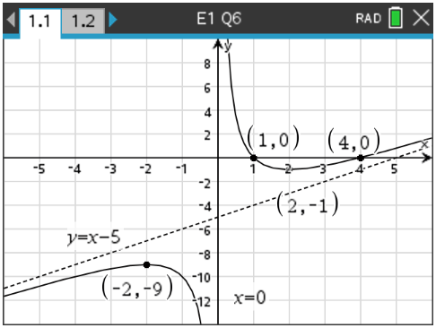

Question 3
a.
use
inverting
A1
since the modulus is not needed. A1
M1

b. use inverting
now by partial fractions
M1
A1
since the modulus is not needed.
M1

Question 4

a.
M1
Let be the normal to the plane A1
The equation of the plane using the normal through the point

b. The plane has a normal and
the line
has a direction and
let be the angle between the line and the plane, let be the angle between the line and the normal to the plane, then
A1
M1
A1
Question 5

a.

let M1
A1

b.
expanding
M1

c.
M1

d. is the real part of one of the solutions to
so that
and
Now and is in the second quadrant so

Hence A1

Question 6
a. be the total of four independent carrots
M1
A1
b.
A1
Question 7

To prove is divisible by 100 for all
Base case . This is divisible by 100. A1
The statement is true when
Assume it is true when so that is divisible by 100, so that
we can write where so A1
Now consider
M1 where so it is divisible by 100.
Since it is true when and assuming it is true when then it is true when A1
, so by the principle of mathematical induction, it is true for

Question 8

a.
M1
M1

b.
A1
A1
we are in the first quadrant
so therefore the modulus is not needed
A1

Question 9

A1
integration by parts
M1
A1

End of detailed answers for the

2024 Kilbaha VCE Specialist Mathematics Trial Examination 1

Kilbaha Education (Est. 1978) (ABN 47 065 111 373)  PO Box 3229  Cotham Vic 3101  Australia | PayID: 47065111373  Email: kilbaha@gmail.com  Tel: (03) 9018 5376  Web: https://kilbaha.com.au

